Institutional Student Learning Outcomes (ISLO) Academic Assessment Process
Prepared by Rachelle Barrett, Interim Chair Executive Committee of the Assessment Commission
5/6/22
Applicable regulations:
1.C.6 Consistent with its mission, the institution establishes and assesses, across all associate and bachelor level programs or within a General Education curriculum, institutional learning outcomes and/or core competencies. Examples of such learning outcomes and competencies include, but are not limited to, effective communication skills, global awareness, cultural sensitivity, scientific and quantitative reasoning, critical analysis and logical thinking, problem solving, and/or information literacy.

Outcomes:
Oregon Tech's Institutional Student Learning Outcomes (ISLOs) support Oregon Tech's institutional mission and core themes. The outcomes and associated criteria reflect the rigorous applied nature of Oregon Tech's degree programs.

Oregon Tech students will:
- communicate effectively orally and in writing;
  - engage in a process of inquiry and analysis; including problem-solving & information literacy, critical analysis & logical thinking
- make and defend reasonable ethical judgments;
- collaborate effectively in teams or groups;
- demonstrate quantitative literacy & reasoning;
- explore diverse perspectives, including cultural sensitivity & global awareness.

Administration:
The Assessment Executive Committee guides campus efforts in institutional academic assessment. The major focus of these efforts is the ongoing assessment of institutional learning outcomes (ISLOs) formerly known as ESLO. The committee provides a cycle for assessment of the ISLOs and distributes tools for assessment at both institution and program levels. The ISLO committees define the outcomes and criteria for instruction and assessment of the specific subject areas. They develop and update a rubric guide and focus on facilitating University wide actions specific to the subject area. The Commission on College Teaching (CCT) may provide guidance on instruction and teaching tools and the General Education Advisory Council (GEAC) reviews ISLO performance and implements actions in the general education classes not associated with a specific program.

Cycle:
ESLO assessment changed from a six-year to a three-year cycle in AY 2020. A three year cycle consists of a year of Planning, a year of Assessment, and a year of action.

Plan Year: Is a focus on faculty design of assignments, rubrics and assessment activities to be implemented in the following academic year. These actions are informed by the professional development that occurred during the previous act year. At the end of the academic year, a planning report identifying which course work will provide data for the following year is submitted along with the regular assessment report. Data that must be submitted in this report include: the course, the assignment, the number of artifacts that will be evaluated, the assessment criteria and the performance outcome of achievement for the ESLO that will be measured.

Assess Year: Student achievement on the ESLO by the previously specified performance criteria is collected and interpreted as met or not met during the academic year using the CLO worksheets. A month after a class is complete, the CLO worksheets will open for data collection. ESLO should be aligned with PSLO and CLO where applicable. A summary report of the data collected will be reviewed by faculty at the beginning of the following academic year.

Act Year: Is a year to take actions. Faculty review the collected data from the previous year at Convocation and provide their interpretations compared with previous data. Programs identify gaps in instruction or resources needed to improve student performance. Committee reviews trends in the data and program feedback to develop University wide actions. Actions include closing the loops, trying strategies and re-measuring, and engaging in professional development. The purpose of the Action year is to improve on student success.

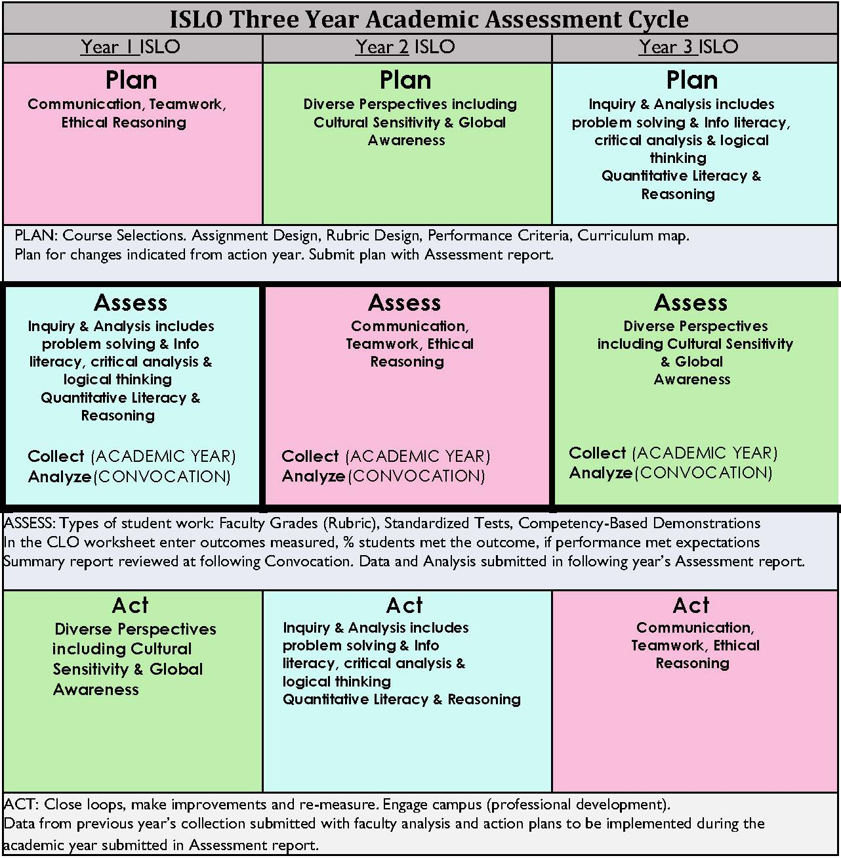

Documentation
Documentation will be collected through the academic year and provided to the university annually in the form of an annual report.
- Programmatic Curriculum Map – Each Program will designate within the curriculum map courses where ISLO are assessed and at what level (Foundational, Practice, Capstone)
  - Foundational expertise is introduction to the concept
  - Practice expertise is built upon foundational information and utilized within programmatic course work as students become more familiar with the concepts
  - Capstone expertise is an experience where a student will bring together multiple ISLO within their practice and are able to apply them to their future professional life
- Course Learning Outcomes Worksheets – Each faculty member will enter data on student performance on assignments aligned with the year’s ESLO. Assignments will be designed and graded by faculty responsible for teaching the course.
  - Instructors will determine their own criteria for demonstration of proficiency on the outcome for the course.
  - Programs will determine criteria for % of students demonstrating proficiency indicates the standard of success has been met for the course.
- Assessment year end report – summarized data reported on the outcomes will be published in the annual report produced by the executive assessment committee.
- ESLO committee annual reports – Each outcome will have a committee that includes faculty subject matter experts. These committees will take actions on the outcomes in the form of community engagement, faculty education or other actions as necessary to improve the education on these outcomes within the OIT community. These actions will be documented in an annual report due at the end of the academic year.
- Program annual reports – Actions taken within the program on these outcomes will be documented in programmatic annual reports.

Reference: https://www.oit.edu/sites/default/files/document/2018-2019-geac-report.pdf

